**Title:**

NY incontinence supply diagnosis restriction policy

**Unresolved Sub Rule Description:**

If any of the following incontinence product codes is billed and an appropriate diagnosis code is not submitted on the claim then deny the code with reason The Diagnosis Codes On The Claim Do Not Support The Billed Procedure Code.

HCPCS: A4554, T4521, T4522, T4523, T4524, T4529, T4530, T4533, T4535, T4537, T4539, T4540, and T4543

ICD: N39.41, N39.3, N39.46, N39.42, N39.43, N39.44, N39.45, N39.490, R39.81, N39.3, R15.9, R15.0, R15.1, R15.2

**Resolved Sub Rule Description:**

If any of the following incontinence product codes is billed and an appropriate diagnosis code is not submitted on the claim then deny the code with reason The Diagnosis Codes On The Claim Do Not Support The Billed Procedure Code.

HCPCS: A4554, T4521, T4522, T4523, T4524, T4529, T4530, T4533, T4535, T4537, T4539, T4540, and T4543

ICD: N39.41, N39.3, N39.46, N39.42, N39.43, N39.44, N39.45, N39.490, R39.81, N39.3, R15.9, R15.0, R15.1, R15.2

**Reason Code and Description:**

00231 - The Diagnosis Codes On The Claim Do Not Support The Billed Procedure Code*.*

**Sub Rule Notes:**

This rule is based on NY state Medicaid Guidelines.

**Script:**

The billed item, <CPT> (<CPT_DESC>), was denied because it was not billed with a required diagnosis, per our policy, which is based on New York Medicaid Guidelines.

**Rationale:**

According to our policy, which is based on New York Medicaid Guidelines, when an incontinence product is billed, the acceptable diagnosis must also be billed on the claim form.

**Claim Types:**

P, A, F, I, O, S

**Subrule DOS From (in Props Tab):**

01/01/1753

**Subrule DOS To (in Props Tab):**

12/31/9999

**Links:**

Practitioners Ordering Incontinence Products – 10/1/2015

<https://www.emedny.org/ProviderManuals/communications/Incontinence_Prescriber_Communication_ICD-10_Quantity_Tool.pdf>

**Reference Details:**

On the only page, state mentions list of diagnosis codes which are acceptable.

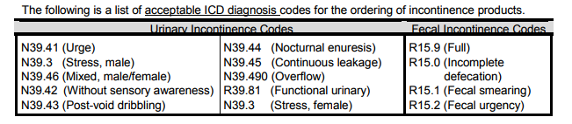

**Client Grid:**

